

Ex

**Fixed Gas Detector & Monitor**

**Operation Manual**

(VER 1.0)

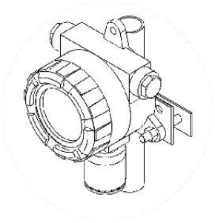

**Ningxia MaiYa Sensor Technology Development Co., LTD**

**E: office@maiya-sensor.com Web: https://www.maiya-sensor.com**

**Catalogue**

**Important notes 1**

**[Remind statement 2](javascript:;)**

**1.Product overview 3**

**2.Product technical index and structure 4**

2.1 Technical Specifications 4

2.2 How the detector works 4

2.3 Monitor composition system 4

2.4 Structure diagram of the monitor 5

2.5 Internal Structure 6

**3.Product installation 7**

Attentions 7

3.1 Dimension of Device 8

3.2 Installation 8

3.3 Cable Connection 9

**4.Start up 14**

Zero setting 15

Calibration 12

**5.Basic Setup 16**

5.1 Calibrating function modules 16

5.2 Display Function Modules 16

Zero setting 19

Span calibration 20

Set the range 20

Set the first alarm point 21

Set the secondary alarm point 21

Unit selection 21

Set Channels 21

4-20mA calibration 22

**TIPS 23**

**6.Common problems and solutions 24**

 **Important notes**

◆ Before installing, operating, and maintaining the device, read the technical

manuals carefully.

◆ Pay special attention to warnings and cautions.

◆ The installation process and operation must strictly comply with the relevant

national recognized standards and requirements.

◆ Any operation inside the monitor must be performed by a professional.

◆ Before opening the monitor housing, the power must be disconnected to reduce

the risk of ignition by dangerous gases.

◆ Do not open the junction box/housing or replace the sensor in the presence of

dangerous gases.

◆ The monitor must be safely grounded to prevent RF interference.

◆ The sensor may contain corrosive solution, so be careful when handling.

◆ Do not expose the sensor to temperatures exceeding the recommended range.

◆ Do not place the sensor in organic solvents or flammable liquids.

◆ When the use period of the sensor reaches, it should be safely treated from the perspective of environmental protection, in accordance with the requirements of

local waste management and environmental regulations.

◆ The electrochemical sensor may produce toxic fumes, so it should not be

incinerated.

 **Remind [statement](javascript:;)**

**The following warnings are mentioned throughout the manual.**

Warning: Be aware of any danger or insecurity that may result in a serious accident or

injury.

Note: Be aware of any hazards or unsafe hazards that may result in personal injury or

damage to products or property.

Remarks: Useful/additional information.

Please contact us for any information that is not mentioned in this information, or that needs

to be added or corrected.

**The Company reserves the right to correct or modify the information in the document**

**without notifying any person or organization.**



**1.Product overview**

This equipment can be used in the national provisions of zone 1 dangerous place.

The monitor can use the following sensors, resulting in five different types of monitors:

■ **Combustible gas（ LEL）**  **Poison gas（ ppm）**

■ **Oxygen（%V/V）**

**TVOC（ ppm）**

**Non-Methane Hydrocarbon（ ppm）**

**Other harmful gases（ ppm）**

Users can know the monitor type from the label content in the display window. Regardless of the sensor used, it is very easy to replace.

The type of monitor can be distinguished according to the label on the upper part of the enclosure.

The above monitors operate in the same way and provide a standard three-wire 4-20 mA current output or a standard four-wire RS485 voltage signal output to the dedicated

controller or third-party device connected.

**The monitor as a whole includes：**

■ A monitor housing that can be equipped with sensors ;

■ Mounting bracket；

■ Cable wire 1m for Power-supply;

**In addition to the standard module, other functional modules can be selected. The optional modules include：**

■ ZigBee® wireless data transfer module ;

■ Embedded 220V power input and output module ;

**The design, manufacture and verification of this product comply with the following national standards：**

GB15322.1-2003 《可燃气体监测仪技术要求和试验方法》

GB 3836.1-2000 《爆炸性气体环境用电气设备 第 1 部分 ：通用要求》



**2.Product technical index and structure**

**2.1 Technical Specifications**

Measurement principle(sensors): electrochemistry, catalytic combustion, infrared, photoion (PID), semiconductor；

**Response time**：

.Combustible gas less than 30S (T90)；

.Adsorbent gas (ammonia, chlorine, etc.) less than 40S (T90);

.Other toxic gas less than 20S (T90);

**Remarks**：T90 represents the time to reach 90% of the final reading； **Explosion-Proof**： Exd IICT6 (flame-proof type)；

**IP grade： IP65**；

**Working Temperature**： -10℃ ~ 55℃ ;

**Working humidity**： 10％ ～95% RH；

**Power supply**： DC24V (Allowable range of monitor operating voltage: DC12-30V)； **Maximum power consumption**: less than 3W；

**Output mode**: 3-wire 4-20mA. RS485-Modbus or 2-wire 4-20mA for optional;

**Connection thread**: G1/2 M20 or G3/4 optional (other sizes required);

**Boundary dimension**： 140mm*195mm*90mm；

**Main material**: cast aluminum, surface spray plastic ;

**Weight**: 2.05kg(including package);

**2.2 How the detector works**

The detection element of the monitor adopts international gas sensitive element, which can convert the concentration signal into the corresponding signal and transmit it to the

controller according to the concentration of the surrounding gas.

**2.3 Monitor composition system**

The gas detection system consists of sensor, amplifier circuit and alarm component.

**2.4 Structure diagram of the monitor**

The monitor is composed of a shell, a sensor kit and a mounting bracket. The shell is mainly composed of a surface shell, a bottom shell and an O-seal ring and cable into the hole assembly, the shell plays the role of flameproof and protection. The sensor kit consists of a gas sensitive sensor and a protective cover (see the monitor structure diagram).

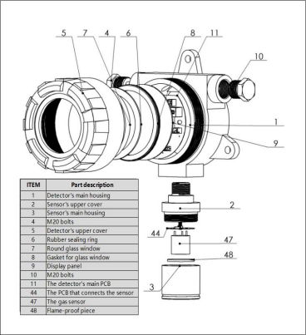

**2.5 Internal Structure**

The monitor is composed of the monitor mainboard, monitor setting board, monitor display (optional) and other parts.

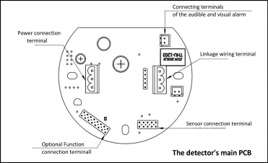

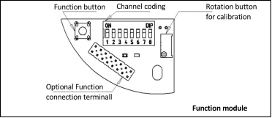



**3.Product installation**

**Attentions**

The monitor has a certificate of quality;

The most common causes of the signal drift are the formation of ground loops and poor

shielding. Use appropriate grounding technology to improve resistance to EMI interference.

When selecting the installation location, pay attention to the following：

●When the gas being measured is lighter than air (e.g., Methane), the monitor should be installed at a high position. Preferably with a collecting hood.

●When the gas being measured is heavier than air (e.g., butane), the monitor should be installed in a low position.

If installed outdoors, pay attention to the influence of external factors, such as rain or water injection.

If necessary, install the monitor in the pipe using appropriate pipe mounting elements；

Check relevant production line conditions. For example, butane is usually heavier than air, but if the gas is produced under heating or pressure, it may rise before it sinks.

When necessary, the following relevant personnel may be consulted:

● Experts with expertise in gas dispersion;

● Familiar with the knowledge of process equipment system and related equipment; ●Safety and engineering personnel.

**3.1 Dimension of Device**

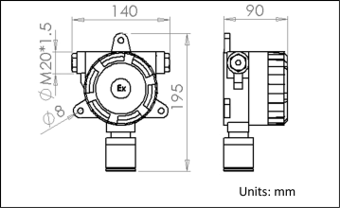

**3.2 Installation**

The installation can be wall mounted or duct mounted.

● Wall installation: first use the impact drill (hammer) in the wall to drill the corresponding size of the hole, Then put the bolt, tube expansion into the hole, screw the nut can make the bolt, tube expansion, monitor and wall between the expansion become a whole.

● Pipe installation: THE fixed pipe is SANDWIChed between the SPLint and the fixed plate, and the hole on the fixed plate corresponds to the two holes on the lower part of the

monitor, and the three are tightly locked with the fixing bolts and nuts.

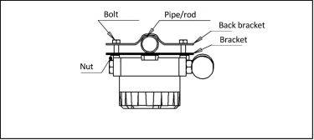

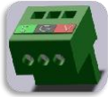

**3.3 Cable Connection**

Rotate the upper cover of the monitor clockwise, open the upper cover and pull out the

display panel (optional). At this time, the main board of the gas monitor can be seen (see the internal structure diagram in Section 2.5). The green pluggable terminal on the left side of the mainboard is the terminal block for power supply and signal transmission. The green

pluggable terminal on the right of the mainboard is the linkage terminal block, which is used to connect the signal end of the linkage device (passive).

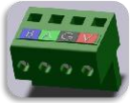

As shown in the figure above, the terminal is removed. When wiring, loosen the screw with a flat-head screwdriver, insert the wire into the wiring port, tighten the screw and insert the whole terminal back to the original circuit board seat.

**3.3.1 4～20mA Configuration**

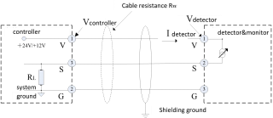

The 4-20 mA version is connected using a 3-core cable. Where, V is the DC 24V positive pole of the power supply; G is the common end of the power supply or the negative pole of the

DC power supply; S is the positive pole of the 4-20mA signal; The negative terminal of the 4-20mA signal is in common with the common end of the power supply.

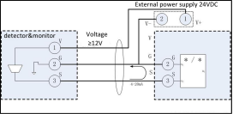

When connected with a third party control system (PLC or DCS), sometimes there are only S+, S- two terminals on the device. In this case, connect the V+ of the power supply to the V terminal of the monitor, connect the V- of the power supply to the G terminal of the monitor in parallel with the S- of the device, and connect the S+ of the device to the S terminal of the monitor.

In view of the voltage drop caused by wire resistance, ensure that the minimum supply voltage of the monitor meets the operating voltage requirements.

The maximum cable resistance

*RW*

can be calculated according to the following formula：



For example, if the power supply voltage of the controller is 24V, the minimum operating voltage of the monitor is 12V, and the maximum operating current is 100mA(combustible),

then the maximum allowable value of

*RW*

is 120 ohm (combustible). The following table

lists the maximum cable transmission distance for different cable parameters under 12V

voltage drop. This form is for reference only. When used, the actual cable parameters should be less than the calculated maximum cable transmission distance.

|  |  |  |  |  |
| --- | --- | --- | --- | --- |
| **cross sectional area** | | **Km resistance**（ **ohm**） | | **Max transmission distance** |
| **mm2** | **AWG** | **cable** | **circuit** | **m** |
| 1.0 | 17 | 18.1 | 36.2 | 3314 |
| 1.5 | 16 | 12.1 | 24.2 | 4958 |

**3.3.2 RS485-BUS configuration**

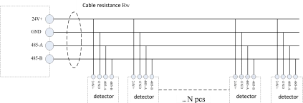

The RS485 bus version uses a 4-core cable. Where, V is the DC 24V positive pole of the

power supply; G is the common end of the power supply or the negative pole of the DC

power supply; A is the positive terminal of the RS485 signal. B indicates the negative terminal of the RS485 signal.

When debugging the RS485 bus version, pay special attention to the connection mode of multiple monitors and the cable resistance. RS485 bus should be connected hand in hand (in series) connection mode to eliminate the reflection interference caused by the star structure.

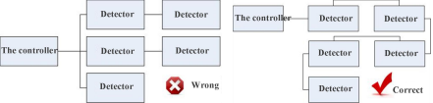

The maximum cable resistance can be calculated according to the following formula：



For example, if the supply voltage of the controller is 24V, the minimum operating voltage of the monitor is 12V, the maximum operating current is 100mA(combustible), and the number

of monitors is 32, the

*RW*

maximum allowable value is 3.75ohm. The following table lists the

maximum cable transmission distance for different cable parameters under 12V voltage reduction. This form is for reference only.

|  |  |  |  |  |
| --- | --- | --- | --- | --- |
| **cross sectional area** | | **Km resistance**（ **ohm**） | | **Max transmission distance** |
| **mm2** | **AWG** | **cable** | **circuit** | **m** |
| 2.5 | 17 | 7.2 | 14.4 | 260 |
| 1.5 | 16 | 12.1 | 24.2 | 154 |

Remark: Steel armored cable is recommended. Wire A cable with a cross-sectional area of 0.5-1.5mm can be selected based on the distance between the monitor and the controller. Ensure that the crimping cover is properly installed and securely fastened. If there are too many mounts on the bus and cables are too long, to avoid increasing the difficulty of

construction, debugging, and maintenance, it is strongly recommended to adopt the

multi-bus method and evenly distribute the probes on each bus. Or add a relay device such as an RS485 hub or trunk power supply to the bus to change the topology of the RS485 port.

**3.3.3 Terminal wiring diagram**

All connections are made through terminal blocks in the monitor housing.

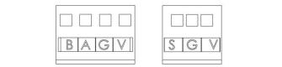

|  |
| --- |
|  |

The monitor is connected to the control device through three (four) terminals labeled

V,G,S(V,G,A, B). The terminal block structure is shown in Figure. For details about terminals and their functions and specifications, see the following table.

|  |  |  |  |
| --- | --- | --- | --- |
| **Symbol** | **Description** | **Function** | **specification** |
| V | VCC+ | power supply | +24V DC |
| G | VCC-/GND | GND |
| S | Branch current signal | signal output | 4-20mA |
| A | Bus differential signal + | signal output | RS485A( +) |
| B | Bus differential signal - | signal output | RS485B(-) |

**\* 2-wire 4-20mA terminal**

♦ The 2-wire system detector provides only 2 terminals V and S, as shown follow picture.

♦ V is connected to the power supply 24VDC of controller, S is connected to the S terminal of controller, as shown in the following figure.

(**Note: Connect all cable first, and then turn on the power.**)

 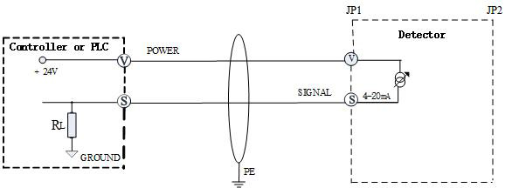

♦ The 2-wire detector does not support high voltage and high current, so it does not support sound and light alarms or relay output or screen backlight.



**4.Start up**

It describes how to power on the monitor for the first time for each type of monitor.

1. Add external power supply to the monitor; Ensure that the minimum supply voltage at terminals V and G meets the operating voltage requirements. A digital multimeter is used for detection.

2. Cover top cover.

3. After the alarm starts normally, the concentration value will rise in a short time (the sensor is not stable), and then gradually decrease to zero (the sensor is stable).

4. After the alarm starts normally, it is necessary to preheat the sensor so that the sensor performance is stable.

5. Wait for the monitor to complete the warm-up process. The preheating time is determined by the characteristics of the sensor itself, and the preheating process may include numerical fluctuations and generate alarm signals. At this time, please close the linkage equipment as far as possible, and after the heat engine, the monitor will be in the basic operation state.

Here warm-up time of some kinds of gas:

|  |  |  |  |
| --- | --- | --- | --- |
| Gas | warm up time | Gas | warm up time |
| LEL | 10s | CO | 20s |
| CO | 20s | H2S | 20s |
| SO2 | 20s | HCN | 20s |
| CL2 | 30s | NH3 | 2min |
| O2 | 20min | HCL | 2h |
| ETO | 10h | NDIR sensor | 5min |

It is recommended that zeroing and calibration be carried out every 3 to 4 months or regularly according to local regulations. The detector has been aged, tested, done zeroing and calibration before leaving the factory. Usually, the user can zero and calibrate the

detector again before using it to ensure its accuracy.

**Zero setting**

The detector zeroing process is similar to the calibration process described below. When ensuring that the ambient gas does not contain the measured gas, it can be directly zeroed. Otherwise, zero gas (generally using nitrogen) should be used for zeroing. In the zeroed state, the display shows zero.

**Calibration**

It is recommended to use 80% of the range of the alarm gas to calibrate the alarm, to ensure that the concentration of the alarm display information is linear. After the calibration, the calibration device is removed, and the alarm displays the gas concentration in the current environment.



**5.Basic Setup**

This section contains all the basic setting functions of the monitor, including two parts. The first part is the calibration function module, which is suitable for the monitor without display standard configuration. The second part is the display function module, which is suitable for the monitor with liquid crystal display.

**5.1 Calibrating function modules**

As shown in Section 2.4, there is a button marked zero, an adjustable rheostat marked range, and a patch status indicator on the module board. The calibration function module board includes two functions: zero adjustment and range adjustment.

**Zero setting:** Power on the monitor and hold down the zero setting button for 10S after the monitor is preheated.

**Calibration:** the monitor is powered on, and after the monitor is preheated, the

standard gas with known concentration is fed into the monitor, and the value on the

controller is observed. When the concentration is stable, rotate the knob to make the value on the controller correspond to the actual standard gas concentration.

**Indicator:** In normal state, the indicator blinks, in communication state, the indicator blinks, and other status indicators are off.

**5.2 Display Function Modules**

The alarm display panel is composed of LED indicator light, LCD LCD screen, etc. The display panel can provide detailed alarm state information display. The following describes the

display panel in detail.

The display panel of the alarm includes a liquid crystal display screen and 2 status indicators. LCD screen can display all kinds of alarm information (will be introduced in the following

content); The following figure shows the working status of the status indicator and the appearance of the display panel.

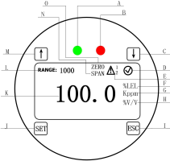

Alarm display panel

Each position in the figure above represents the following：

A Communication indicator light: When the alarm is working normally, the working indicator light is steady on, and the green light quickly flashes 1 after sending and receiving a complete frame of data.

B Alarm indicator light: It blinks slowly for the first level concentration alarm and fault alarm, and blinks quickly for the second level concentration alarm.。

C Down key: when setting the menu, enter the upper menu; To set a value, subtract 1 from the value.

D Normal working identifier of the alarm.

E Concentration alarm: alarm in the first alarm state, display, alarm in the second alarm state, display 。

F Combustible gas concentration unit: gas explosion lower limit unit.

G Toxic gas concentration unit： ppm、 kppm.

H Volume percentage unit of concentration.

I Confirm key: Confirms the result of menu and value Settings.

J Cancel key: Return to the main interface directly.

K Main display area: numerical display of measured gas concentration.

L Range: Displays or adjusts the current range.

M Up key: when setting the menu, enter the next level menu when setting the menu;

When a value is set, the value is incremented by 1.

N Range calibration: When the user calibrates the range of the alarm, the instrument will display the identifier.

O Zero calibration: When the user calibrates the zero of the alarm, the instrument will display the identifier.

**5.2.1 Working Status**

In this mode, the alarm performs the measurement work, and may be in normal and alarm two working states.

**Normal working state:** the system normally carries on the sampling and the display work, the alarm power lamp according to the power supply mode to do the corresponding flashing.

**Alarm working state:** When the concentration value measured by the alarm exceeds the alarm limit value (primary alarm or secondary alarm), it will automatically switch to the alarm working state. In this state, the LCD on the display panel will display the corresponding alarm sign, and the alarm light of the alarm will flash slowly or quickly according to the alarm level.

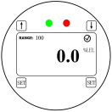

normal working

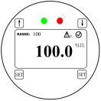

Warning status

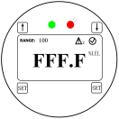

Full/over range working

 Note: When the measured gas over range is detected, the alarm will indicate over range, and the interface will display "FFF.F".

**5.2.2 User Settings**

This product has 8 menu options display, these menus will be set by magnetic rod or key press, the table below lists all the menus and corresponding function description.

|  |  |
| --- | --- |
| **Menus** | **Functional description** |
| Range setting | Range of alarm |
| zero setting | Alarm zero calibration |
| calibration | Span calibration of alarm |
| Primary alarm setting | Set the primary alarm value |
| Secondary alarm setting | Set the secondary alarm value |
| Units Setting | Set the unit of gas measurement |
| Channel settings | Set the bus channel number |
| 4-20mA calibration | Calibrate 4-20mA signal |

**Zero setting**

(1) Power to the alarm, make the alarm stable for 5 minutes (to ensure that the alarm is in pure air);

(2) Press the SET key and the range indication “ RANGE” flashes; (3) Press ↑ to enter the ZERO menu, and“ZERO”flashes;

(4) Press the SET key, the main display area flashes;

(5) Press the SET key again, the interface stops for a few seconds, then the automatic zeroing succeeds;

(6) Press ESC to return to the main menu.

The setting interface is shown as follows:

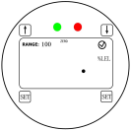

Zeroing state

**Span calibration (Note: zeroing setting before calibration)**

(1) Connect the gas distribution device, power the alarm, stable for 5 minutes；

(2) Fed with calibration gas at a flow rate of 500ml/min. Continue for 2-3 minutes until the value is stable;

(3) Press the SET key, then the“ RANGR ”flashes;

(4) Press ↑ twice to enter the span calibration menu, then“SP”flashes;

(5) Press the SET key to enter the value setting interface, and the value blinks;

(6) Press the SET key then the low digit flickers. Use ↑ and ↓ to change the digit. Press the SET key to move one to the left, the corresponding value flickers, then repeat the operation, use the ↑ and ↓ and SET keys to adjust the display value to the corresponding gas concentration value；

(7) Press the SET key, the span calibration is successful；

(8) Press ESC to return to the main display interface and remove the device.

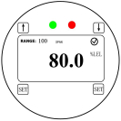

Calibration status

Figure 5-2 Display interface of alarm zeroing and calibration status

**Set the range**

(1) Press the SET key, then the“ RANGE”flashes to enter the range setting interface; (2) Press the SET key to enter the value setting interface, and the low digit flickers;

(3) Use ↑ and ↓ to change the digit. Press the SET key to move one to the left, the corresponding value flickers, then repeat the operation, use the ↑ and ↓ and SET

keys to adjust the display value to the corresponding gas concentration value; (4) Press the SET key, the range setting is successful;

(5) Press ESC to return to the main display interface.

**Set the first alarm point**

(1) Press the SET key and the“ RANGE”flashes;

(2) Press ↑ 3 times ， flickers；

(3) Press the SET key to enter the value setting interface, and the low digit flickers; (4) Use ↑ and ↓ to change the digit. Press the SET key to move one to the left, the

corresponding value flickers, then repeat the operation, use the ↑ and ↓ and SET keys to adjust the display value to the corresponding gas concentration value;

(5) Press the SET key, the first alarm point setting is successful;

(6) Press ESC to return to the main display interface.

**Set the secondary alarm point**

The setting of the secondary alarm point is the same as the primary alarm point. The difference is that in the second step, press ↑ 4 times.

**Unit selection**

(1) Press the SET key and the“ RANGE”flashes；

(2) Press ↑ 5 times,“ ppm”flickers；

(3) Press the SET key to enter the unit setting menu；

(4) Press ↑ and ↓ to switch between ppm, Kppm, %LEL, and %V/V to select the desired unit；

(5) Press the SET key, the unit selection is successful；

(6) Press ESC to return to the main display interface.

**Set Channels**

(1) Press the SET key and the“ RANGE”flashes；

(2) Press ↑ 6 times to enter the 485 communication setting screen. The

communication address of the detector flickers；

(3) Use ↑ and ↓ to select or change the address value.

(4) Press the SET key, the channels setting is successful;

(5) Press ESC to return to the main display interface.

**4-20mA calibration**

(1) Press the SET key and the“ RANGE”flashes；

(2) Press ↑ 7 times, the“ADJ” indecation flickers；

(3) Connect the multimeter in series in the 4-20mA channel. When “0” flashes, adjust the output current by ↑ and ↓ until the ammeter measurement value is closest to 4mA. When “ 100 ” flashes, use ↑ and ↓ to adjust the output current until the ammeter measurement value is closest to 20mA.

(4) Press the SET key, the 4-20mA calibration is successful.

(5) Press ESC to return to the main display interface.

**TIPS:**

This product is intended for industrial hazard zone I or II.

It is recommended that gas monitors be re-calibrated every six months or in accordance with local regulations.

Each gas monitor has been 100% tested before leaving the factory, and the certificate of conformity is attached.

When the sensor service time exceeds the validity limit, replace it in time.



**6.Common problems and solutions**

**1、After power-on, there is no display, and the status indicator does not blink.**

Check whether the cable connection between the controller and the monitor is in good contact. Set the multimeter to the voltage level, connect the red and black gauge pen to V and COM terminal post, and measure whether the voltage between V and G on the monitoring terminal block is within the allowable voltage range.

**2、 No display after power-on, the status indicator is normal.**

Check whether the display module is securely connected to the upper wire of the monitor mainboard. Remove the wire by yourself and reinsert the wire.

**3、After power on, The RS485 bus controller shows failure to be connected.**

● Check the cable connection. Bus wiring should be hand-in-hand wiring;

● If all the probes cannot be connected, it may be a short circuit or misconnection in the bus. In this case, the best way is to remove all the terminals of all the monitors and install them one by one. Troubleshoot the faults during the installation process.

● If a part of the monitor cannot be connected, pay attention to the length of the construction cable, the number of monitors on the bus, line resistance and other factors. To measure the power supply voltage of the probe that cannot communicate. If the voltage is low, add the same type of switching power supply at the low voltage.